Tulsivanam by Diyara Infra


About the property:
- A premium mid-rise residential project in the peaceful locale of Kanadia Main Road, Indore.
- Offers limited and exclusive living with only 24 spacious residences.
- G+6 building with thoughtfully designed 2 & 3 BHK homes ranging from 1308 to 2046 sq.ft.
- Located in Sampat Greens – a serene and well-connected neighborhood.
- Modern elevation with ample natural light, ventilation, and wide balconies.
- Developed by a trusted name in real estate with focus on quality & timely delivery.
- Vastu-compliant layouts for a balanced and harmonious lifestyle.
- Full legal compliance and clear titles.
- Ready-to-move-in premium apartments.
- Ideal for families seeking peaceful yet well-connected living.

Amenities:


Kids’ Play Area


Landscaped Garden & Green Spaces


CCTV Camera


Covered Parking

Pictures:
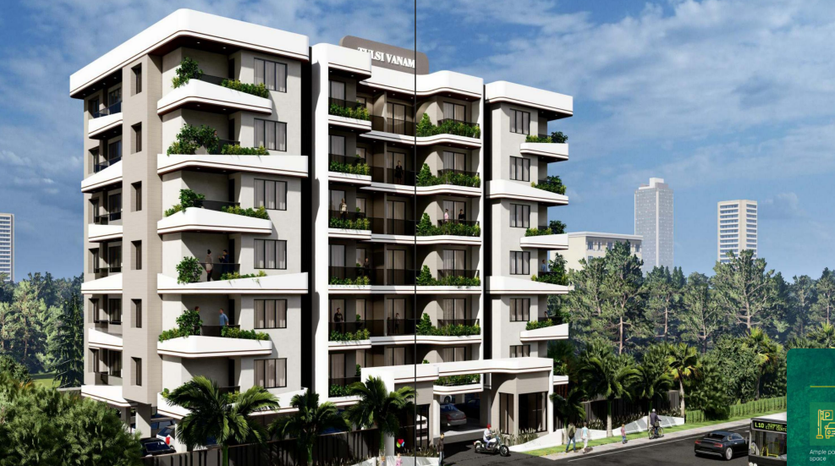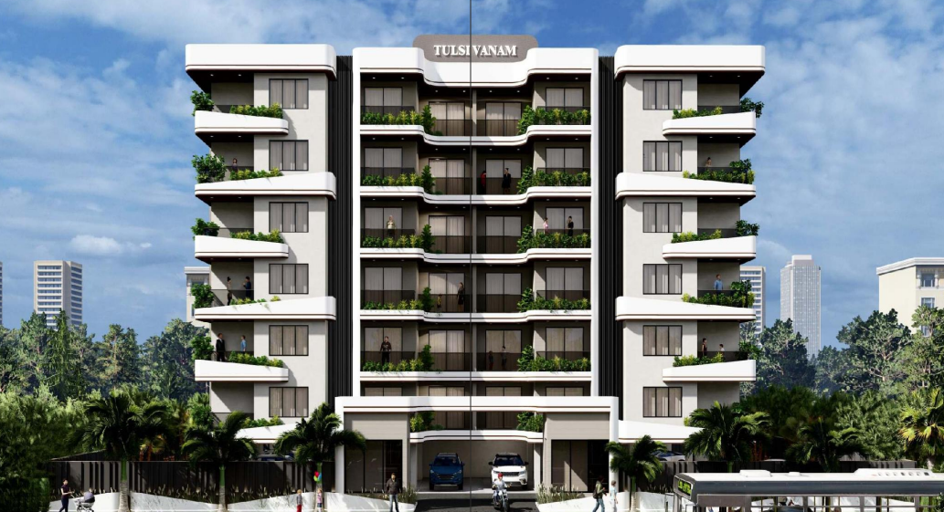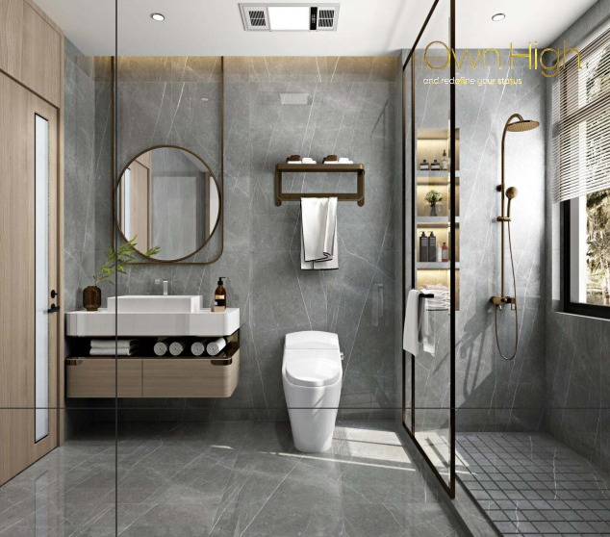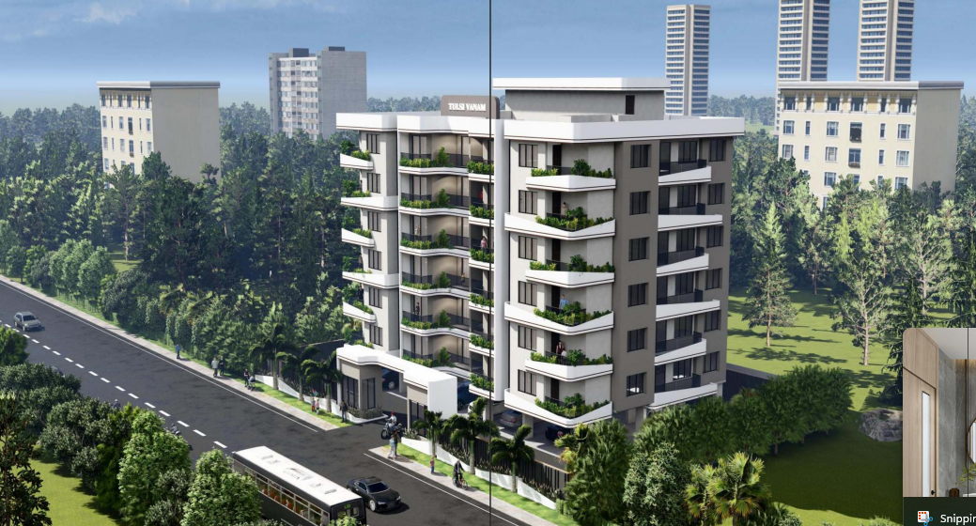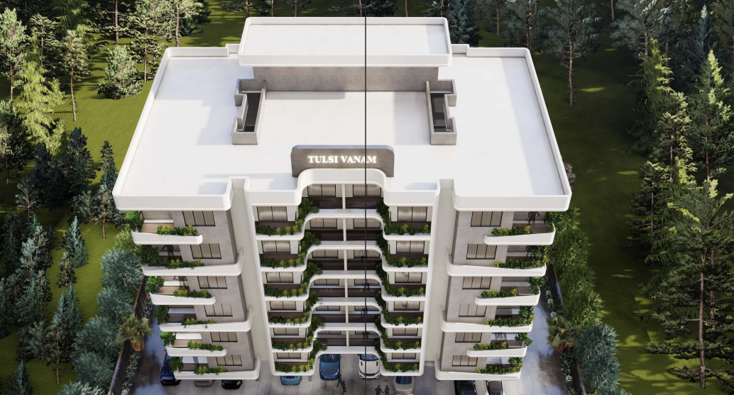

Ground Floor Plan:
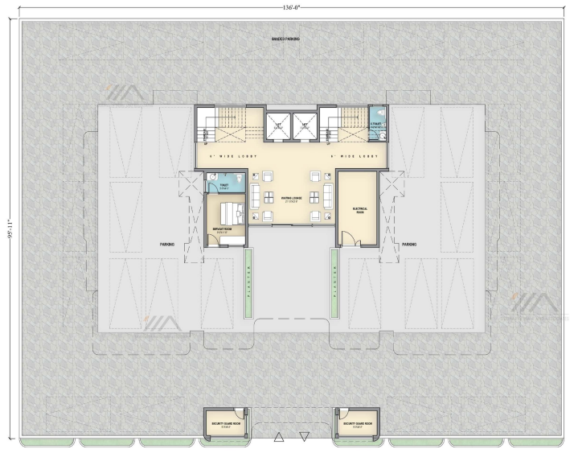

Typical Floor Plan:
(1st, 3rd, 5th)
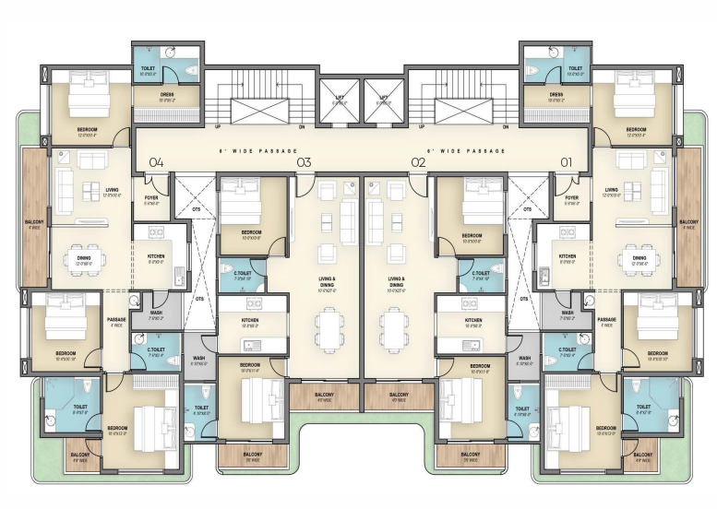
Typical Floor Plan:
(2nd, 4th, 6th)
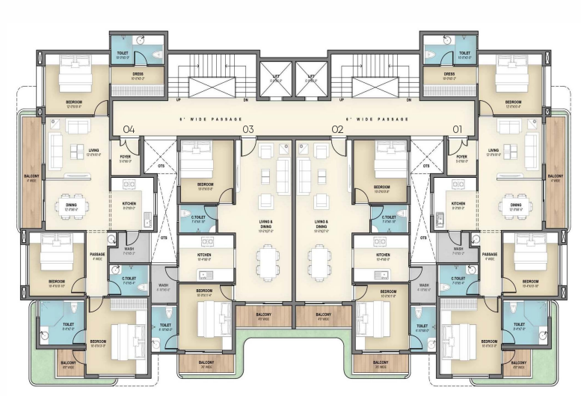
Location Map:
